1. Scanning all ports

import java.io.*;
import java.net.*;
class PortScanner{
public static void main(String args[]){
int count=0;
for(int i=0;i<=65535;i++){
try{
Socket s=new Socket("127.0.0.1",i);
System.out.println("Port "+i+" is busy");
}
catch(Exception e){
count++;
}
}
System.out.println(count+" no. of Ports are not busy");
}
}

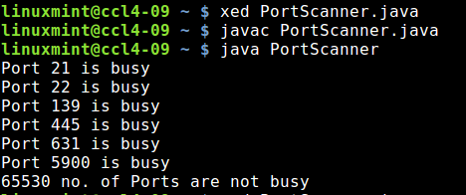

2. Scanning ports in a user defined range.

import java.io.*;
import java.net.*;
class PortScanner{
public static void main(String args[]){
int count=0,start,stop;
start=Integer.parseInt(args[0]);
stop=Integer.parseInt(args[1]);
for(int i=start;i<=stop;i++){
try{
Socket s=new Socket("127.0.0.1",i);
System.out.println("Port "+i+" is busy");
}
catch(Exception e){
count++;
}
}
System.out.println(count+" no. of Ports are not busy");
}
}

